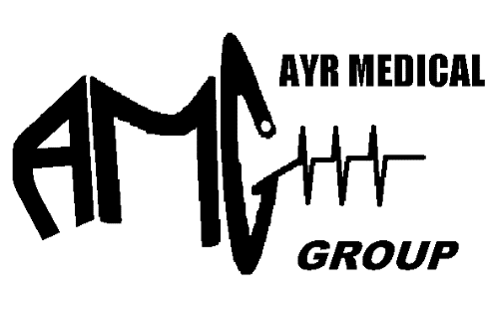
Ayr Medical Group
Patient GP Management Plan Summary

• There are two types of plans that can be prepared by a General Practitioner (GP) for Chronic Disease Management (CDM): GP Management Plan (GPMP); and Team Care Arrangements (TCAs).
• If you have a chronic (or terminal) medical condition, your GP may suggest a GPMP.
• If you also have complex care needs and require treatment from two or more other health care providers, your GP may suggest TCAs as well.
• Your GP or practice staff must obtain your agreement before providing these plans.
• If a provider accepts the Medicare benefit as full payment for the service, there will be no out-of-pocket cost. If not, you will have to pay the difference between the fee charged and the Medicare rebate.
• If you have both a GPMP and TCAs prepared for you by your GP, you may be eligible for Medicare rebates for certain allied health services. It is up to a GP to determine whether you are eligible for these allied health services which must be directly related to the management of your chronic condition.
• The practice nurse can provide support and monitoring between visits to your GP.
• Your GP will offer you a copy of your plan.
• You and your GP should regularly review your plan/s.

Chronic medical conditions
A chronic medical condition is one that has been (or is likely to be) present for six months or longer, for example, asthma, cancer, heart disease, diabetes, arthritis and stroke. There is no list of eligible conditions. However, these items are designed for patients who require a structured approach and to enable GPs to plan and coordinate the care of patients with complex conditions requiring ongoing care from a multidisciplinary care team. Your GP will determine whether a plan is appropriate for you.
GP Management Plan
A GP Management Plan (GPMP) can help people with chronic medical conditions by providing an organised approach to care. A GPMP is a plan of action you have agreed with your GP. This plan:
• identifies your health and care needs;
• sets out the services to be provided by your GP; and
• lists the actions you can take to help manage your condition.

Team Care Arrangements
If you have a chronic medical condition and complex care needs requiring multidisciplinary care, your GP may also develop Team Care Arrangements (TCAs). These will help Chronic Disease Management – coordinate more effectively the care you need from your GP and other health or care providers. TCAs require your GP to collaborate with at least two other health or care providers who will give ongoing treatment or services to you. Let your GP or nurse know if there are aspects of your care that you do not want discussed with other health care providers.
Review of GPMPs and TCAs
Once a plan is in place, it should be regularly reviewed by your GP. This is an important part of the planning cycle, where you and your GP check that your goals are being met and agree on any changes that might be needed.
Referrals for allied health services
If you have both a GPMP and TCAs prepared for you by your GP, you may be eligible for Medicare rebates for specific individual allied health services that your GP has identified as part of your care. The need for these services must be directly related to your chronic medical (or terminal) condition. If you have type 2 diabetes and your GP has prepared a GPMP, you can also be referred for certain allied health services provided in a group setting.

Summary:
- A Medicare rebate is available for a maximum of five services per patient each calendar year. Additional services are not possible in any circumstances.
- If a provider accepts the Medicare benefit as full payment for the service, there will be no out-of-pocket cost. If not, the patient will have to pay the difference between the fee charged and the Medicare rebate.
- Patients must have a GP Management Plan and Team Care Arrangements prepared by their GP, or be residents of a residential aged care facility who are managed under a multidisciplinary care plan.
- Referrals to allied health providers must be from GPs.
- Allied health providers must report back to the referring GP.

Referral validity
A referral is valid for the stated number of services. If all services are not used during the calendar year in which the patient was referred, the unused services can be used in the next calendar year.
However, those services will be counted towards the five rebates for allied health services available to the patient during that calendar year.
When all referred services have been used, or a referral to a different allied health provider is required, patients need to obtain a new referral.
Note: It is not necessary to have a new GPMP or TCAs prepared each calendar year in order to access a new referral(s) for eligible allied health services. Patients continue to be eligible for rebates for allied health services while they are being managed under a GPMP and TCAs as long as the need for eligible services continues to be recommended in their plan.

