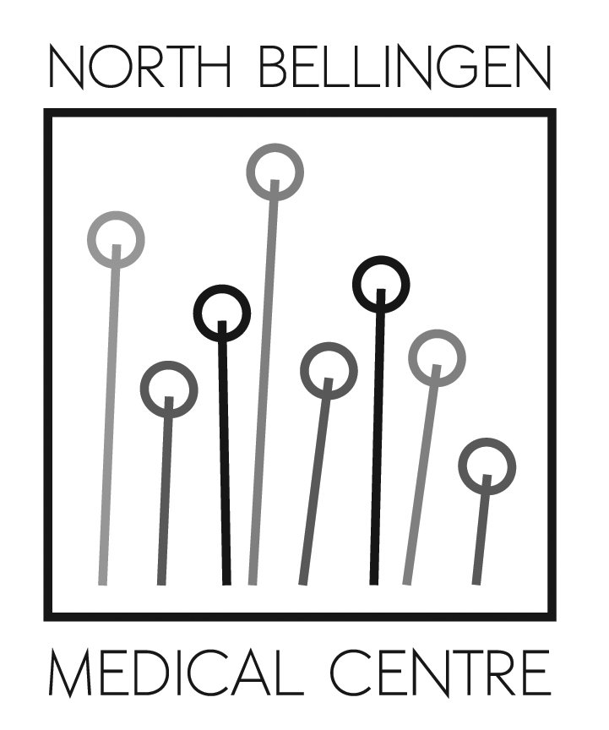

North Bellingen Medical Centre Privacy Policy

North Bellingen Medical Centre is committed to providing quality health care for its patients. As a fundamental part of this commitment principals and staff of the practice recognise the importance of ensuring that our patients are fully informed and involved in their health care.

North Bellingen Medical Centre is, as a NSW health provider in the private sector, bound by the Health Records and Information Privacy Act 2002 (NSW) and the Privacy Act 1988 (Cth) this includes both the Australian Privacy Principles and the NSW Health Privacy Principles. These principles set the standards by which we handle personal information collected from our patients. A copy of both sets of Principles is available for inspection at the reception desk.

As a part of our commitment to providing quality health care it is necessary for us to maintain files pertaining to your health. The files contain the following types of information:

• Personal details (your name, address, date of birth, Medicare number);
• Your medical history;
• Notes made during the course of medical consultations;
• Referrals to other health service providers;
• Results and reports received from other health service providers.

The information held about you is provided by you or arises as a consequence of information provided by you.

Your medical file is handled with the utmost respect for your privacy. The file will be accessed by your medical practitioner, and when necessary, for example in the absence of your usual medical practitioner, by other medical practitioners in the practice. It may also be necessary for our staff to handle your file from time to time to address the administrative requirements of running a medical practice. Our staff members are bound by strict confidentiality requirements as a condition of employment and these requirements will be observed if it is necessary for them to view your records.

At times, to ensure the function of our practice, it may also be necessary to allow external organisations to access our practice and possibly, to view the medical records. Any external organisation that provides service or advice to this practice will be aware of the need to preserve the requirement of state and federal privacy legislation and will be bound by a confidentiality agreement.

Before we disclose personal information to an overseas recipient, we will take reasonable steps to ensure that the overseas recipient does not breach the APPs in relation to the information.

Ordinarily we will not release the contents of your medical file without your consent. However, we advise that there may be occasions where we will be required to release the details of your file irrespective of whether your consent to the disclosure of the information is given.

We advise that as a patient of this practice you have rights of access to any information we hold concerning you. Should you wish to access this information we refer you to our hand-out entitled “ACCESSING YOUR MEDICAL RECORD”.

As part of our commitment to preserving the confidentiality of the information contained in your medical record we advise that strict secure storage policies are observed in this practice. All reasonable steps are taken to prevent any unlawful interference with your electronic records, which are accessible only by staff of this practice and are protected by a security password. Your paper records are kept in a secure room and are accessible only by practice staff. Each member of staff is well versed in the principles and importance of doctor–patient confidentiality.

Should you, at any time, have a query or complaint in relation to the privacy policies in place at this practice please contact our Practice Manager Ms Brenda Mitchell who will be happy to address any concerns you may have. We advise that it is the practice’s policy that any complaint is required to be made in writing and addressed to Ms Mitchell and marked private and confidential. We advise that we will make our best endeavour to address complaints within 30 days of receipt of your complaint.

Should you be unsatisfied with our response to your privacy complaint, you may lodge a written complaint with the Office of the NSW Information and Privacy Commissioner (1800 472 679).

North Bellingen Medical Centre
58 Wheatley St Bellingen NSW 2454
Phone : 0266551755 Fax : 0266559613
Email : nbms@nbms.com.au

